- Pick any app you use daily (such as Zomato, Flipkart, or Instagram) and list 3 keywords or search phrases a new user might type at the Top of Funnel (TOFU) stage, 3 at the Middle of Funnel (MOFU), and 3 at the Bottom of Funnel (BOFU). For each, explain why you placed it in that stage.
Funnel Stage | Keyword / Search Phrase | Why it belongs here
TOFU | Best restaurants near me | The user is exploring options and has not decided where to order.
TOFU | Best food delivery apps | The user is learning about available food-delivery options.
TOFU | Restaurants for dinner | The user knows their need but is still researching choices.
MOFU | Zomato restaurants near me | The user is considering Zomato as a solution and looking at available restaurants.
MOFU | Zomato food delivery offers | The user is comparing offers and deciding whether Zomato is worth using.
MOFU | Best restaurants on Zomato | The user is evaluating specific options available on the platform.
BOFU | Order pizza on Zomato | The user has decided what they want and is ready to order.
BOFU | Zomato order online | Strong transactional intent—the user wants to place an order now.
BOFU | Zomato coupon for my order | The user is close to completing the purchase and wants a discount.

- Download or create a simple content mapping worksheet in Excel or Google Sheets. For your chosen app, fill out one row each for TOFU, MOFU, and BOFU keywords, mapping each to a specific type of content (e.g., blog post, product page, review video) that would match the user's intent.
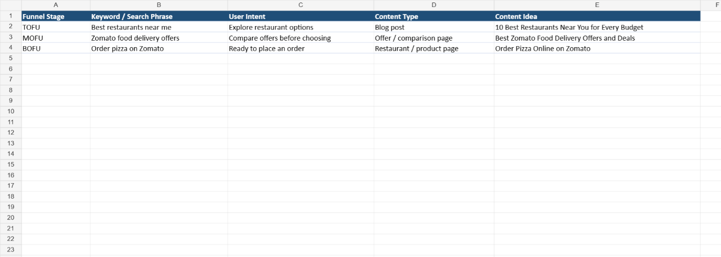

- Write a short scenario where a user moves from TOFU to BOFU for a food delivery app like Swiggy. Describe the keywords they search at each stage and the type of content they interact with along the way.<br><br><em><strong>Hint:</strong> Think about how a user starts with broad research and ends with a specific action (like placing an order).</em>
TOFU (Awareness):
The user searches “best food delivery apps in Ahmedabad” and “best restaurants near me.” They read blog posts and restaurant guides to explore their options.
MOFU (Consideration):
The user searches “Swiggy food delivery offers” and “best restaurants on Swiggy.” They interact with restaurant listings, reviews, ratings, and offer pages to compare options.
BOFU (Decision/Action):
The user searches “order pizza on Swiggy” and opens a specific restaurant/product page. They check the price, delivery time, reviews, and available coupon, then place the order on Swiggy.

- Choose a product or service you are interested in (not the one used in class) and identify one TOFU keyword, one MOFU keyword, and one BOFU keyword. For each, suggest a headline or title for a piece of content that would attract users at that stage.<br><br><em><strong>Constraint:</strong> Your headlines should be catchy and clearly match the user's intent at each funnel stage.</em>
Stage | Keyword | Catchy Headline
TOFU | best places to visit in India | “15 Amazing Places to Visit in India at Least Once”
MOFU | best travel packages for Goa | “Best Goa Travel Packages: Compare Prices, Hotels & Activities”
BOFU | book Goa tour package | “Book Your Goa Holiday Package Today – Easy & Affordable”

